**Experiment 5**

**Aim**: To create a dataflow diagram for the project Object Detection Solutions

**Theory:**

A data flow diagram shows the way information flows through a process or system. It includes data inputs and outputs, data stores, and the various subprocesses the data moves through. DFDs are built using standardized symbols and notation to describe various entities and their relationships.

Data flow diagrams visually represent systems and processes that would be hard to describe in a chunk of text. You can use these diagrams to map out an existing system and make it better or to plan out a new system for implementation. Visualizing each element makes it easy to identify inefficiencies and produce the best possible system.

Data flow diagrams are also categorized by level. Starting with the most basic, level 0, DFDs get increasingly complex as the level increases. As you build your own data flow diagram, you will need to decide which level your diagram will be.

Level 0 DFDs

Also known as context diagrams, are the most basic data flow diagrams. They provide a broad view that is easily digestible but offers little detail. Level 0 data flow diagrams show a single process node and its connections to external entities.

Level 1 DFDs

Are still a general overview, but they go into more detail than a context diagram. In a level 1 data flow diagram, the single process node from the context diagram is broken down into subprocesses. As these processes are added, the diagram will need additional data flows and data stores to link them together.

Level 2 DFDs

Simply break processes down into more detailed subprocesses. In theory, DFDs could go beyond level 3, but they rarely do. Level 3 data flow diagrams are detailed enough that it doesn’t usually make sense to break them down further.

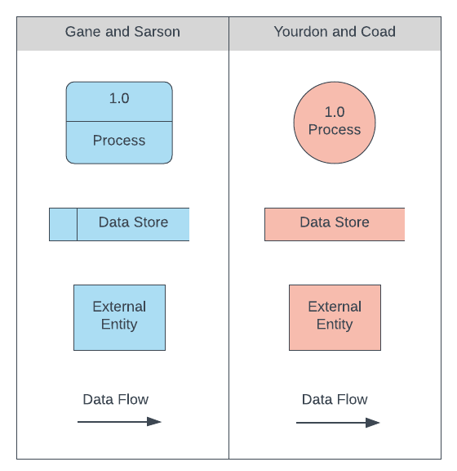DFD Compenents

* Process
* Database/Datastorage
* Enitity
* Data Flow

**Data Flow Diagrams for the Given Projects: Object Detection Solutions**

Data Flow Diagram 1:

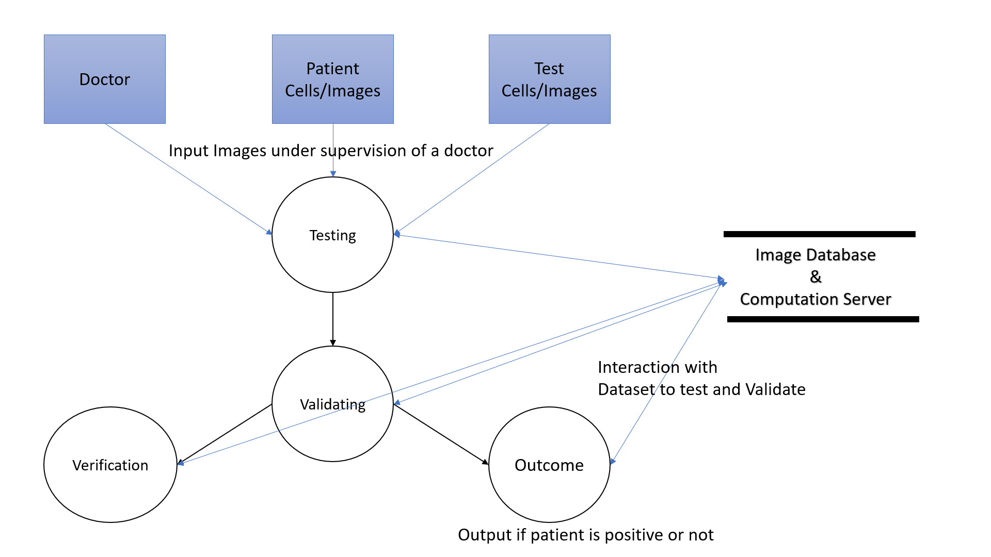

Cancer Cell Detection

Data Flow Diagram for Cancer Cell Detection, it takes the cell image of patient, and recognizes any malignant tumor in it, using Object Detection in Images.

Data Flow Diagram 2:

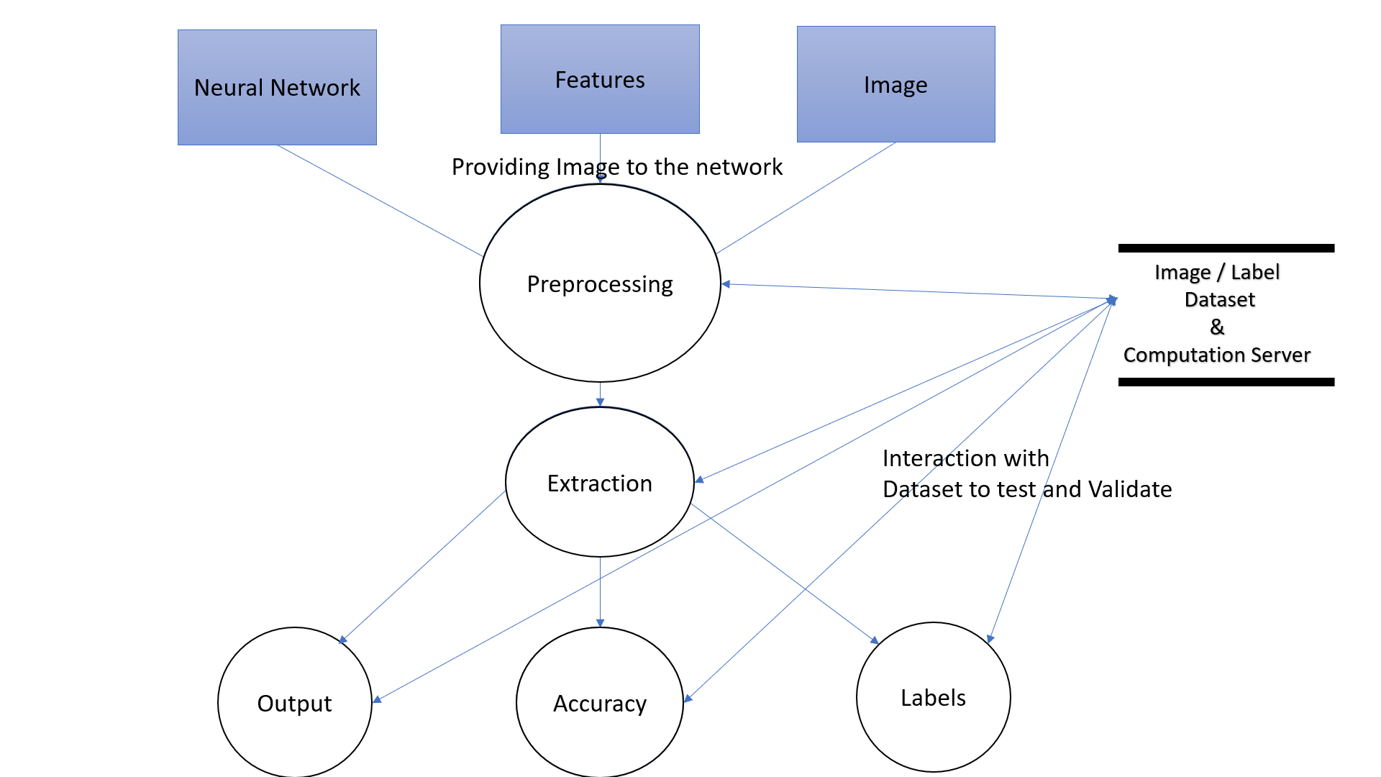

Object Detection Methodology

Data Flow Diagram for Object Detection system, It identifies the object, checks the database for the Label and then gives the user the output.

**Conclusion:**

The Data Flow Diagram for the project Object Detection Solution has been made.